**Gerome Antido**

BSCS 3A

13-2149

**Machine Project 2 – User Manual**

1. Unzip the “Machine Project 2.zip” file

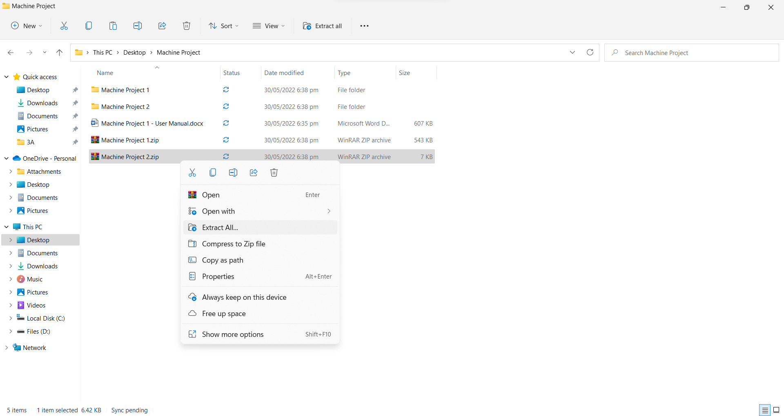

1. Go to the extracted folder and open the “index.html” file.

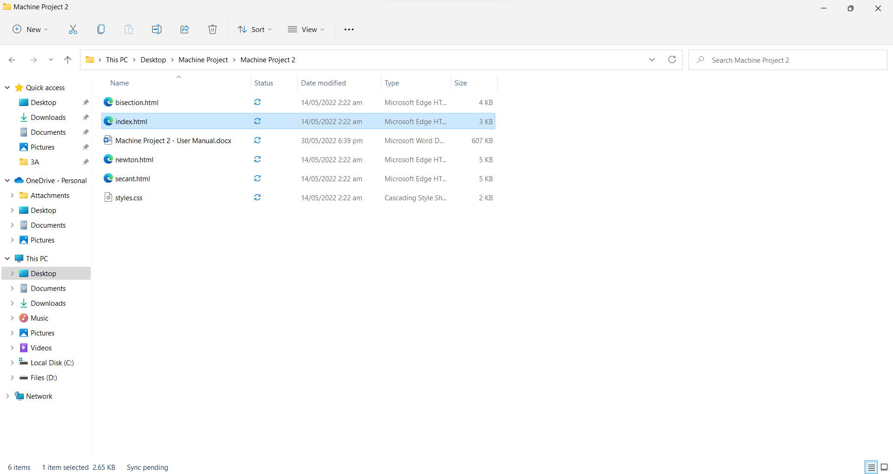

1. From the home page, there you can see three tabs.

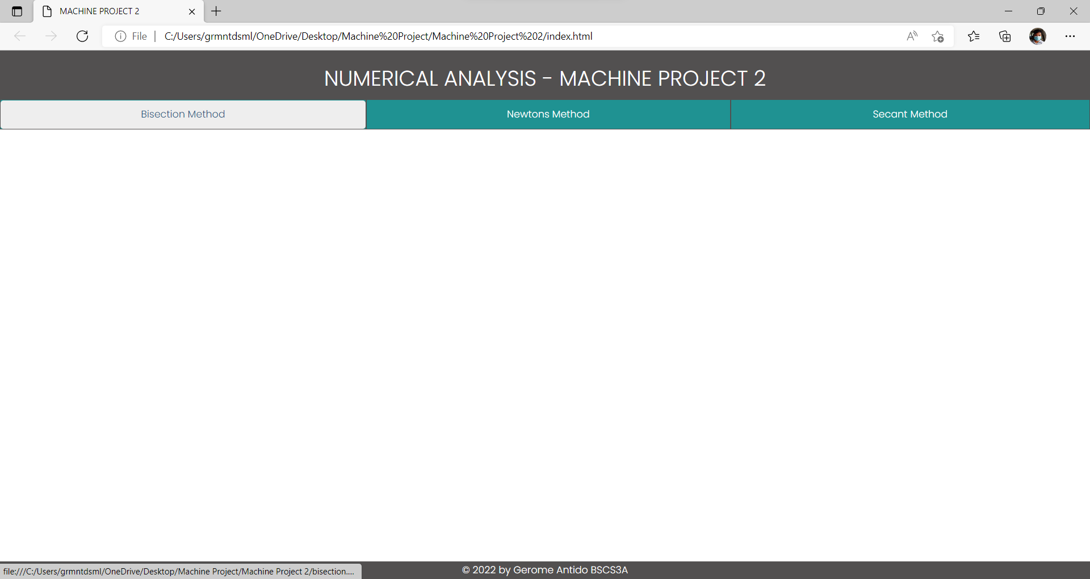

1. In the Bisection Method tab, we can use the Bisection Method to approximate the root.

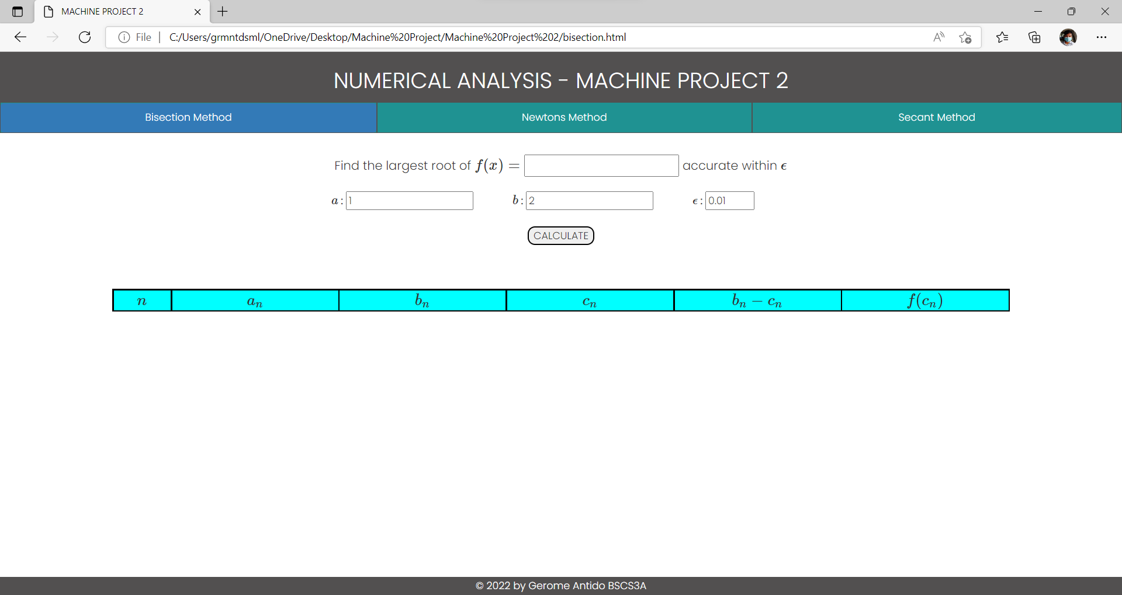

1. Input the function, intervals *a* and *b*, and the value of epsilon and click the “calculate” button.

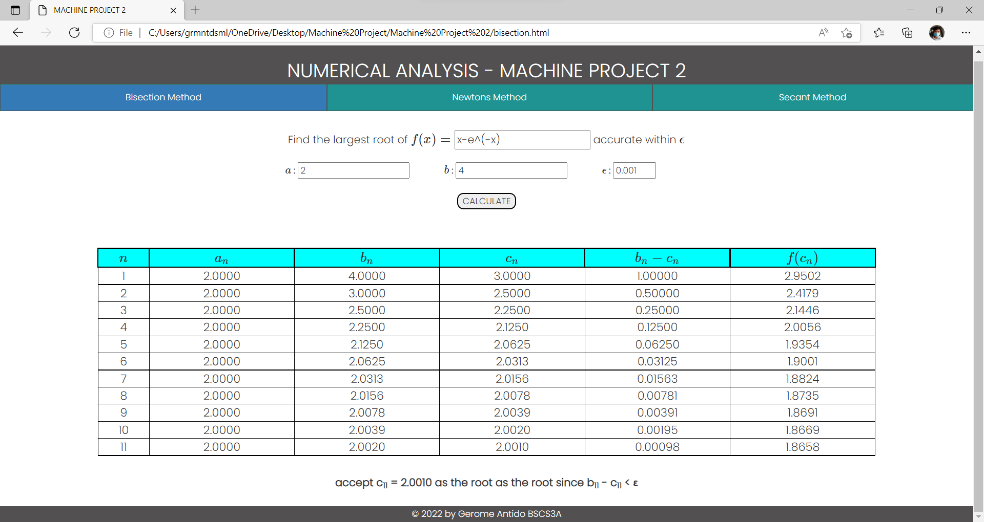

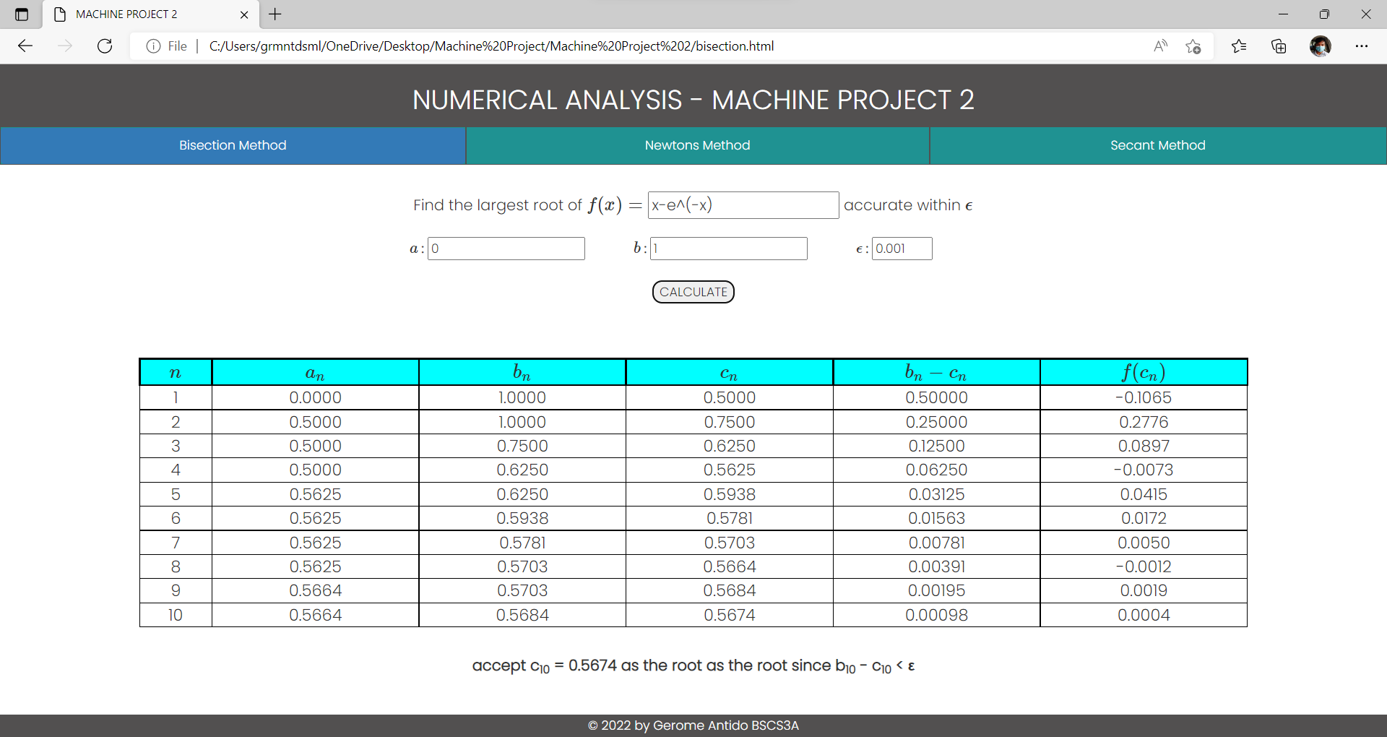

1. In the Newton’s Method tab, we can use Newton’s Method to approximate the root.

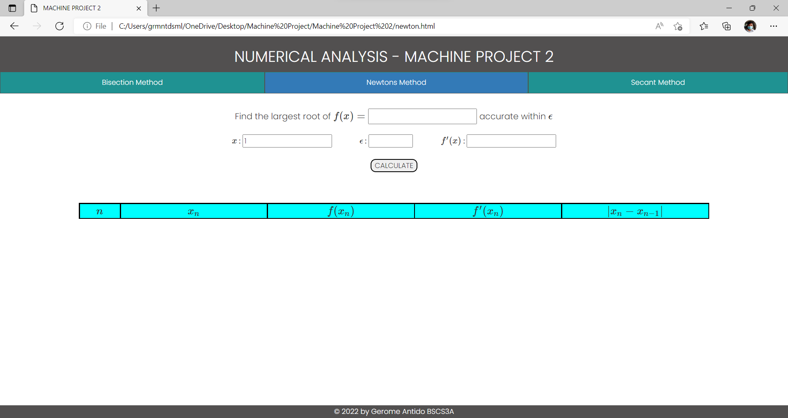

1. Input the function, initial value *x*, the value of epsilon, and the derivative of the function. Then click the “calculate” button.

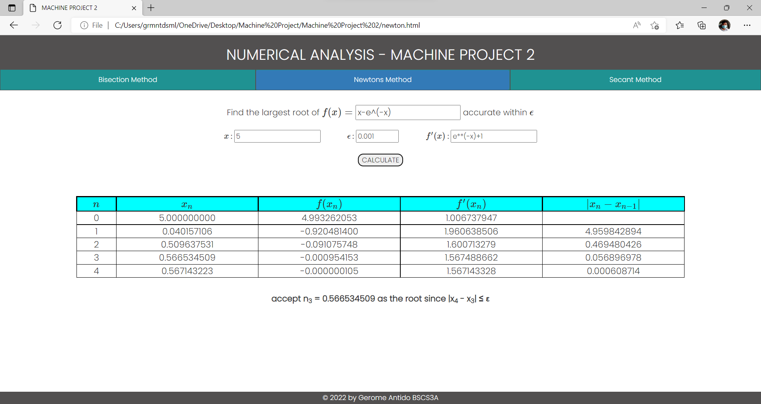

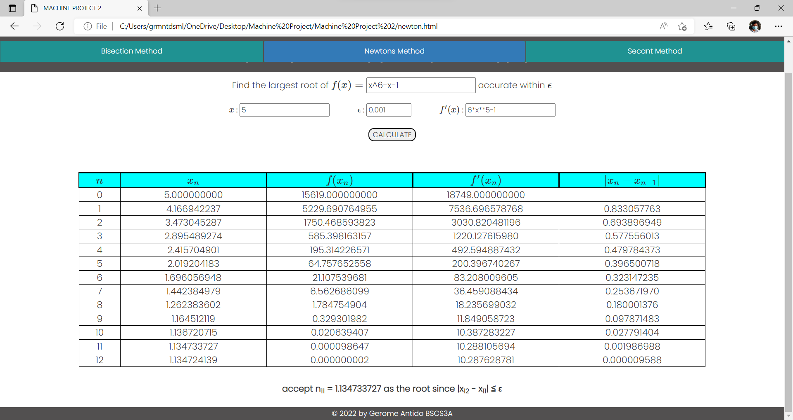

1. Lastly, we can use Secant Method to approximate the root on the Secant Method tab.

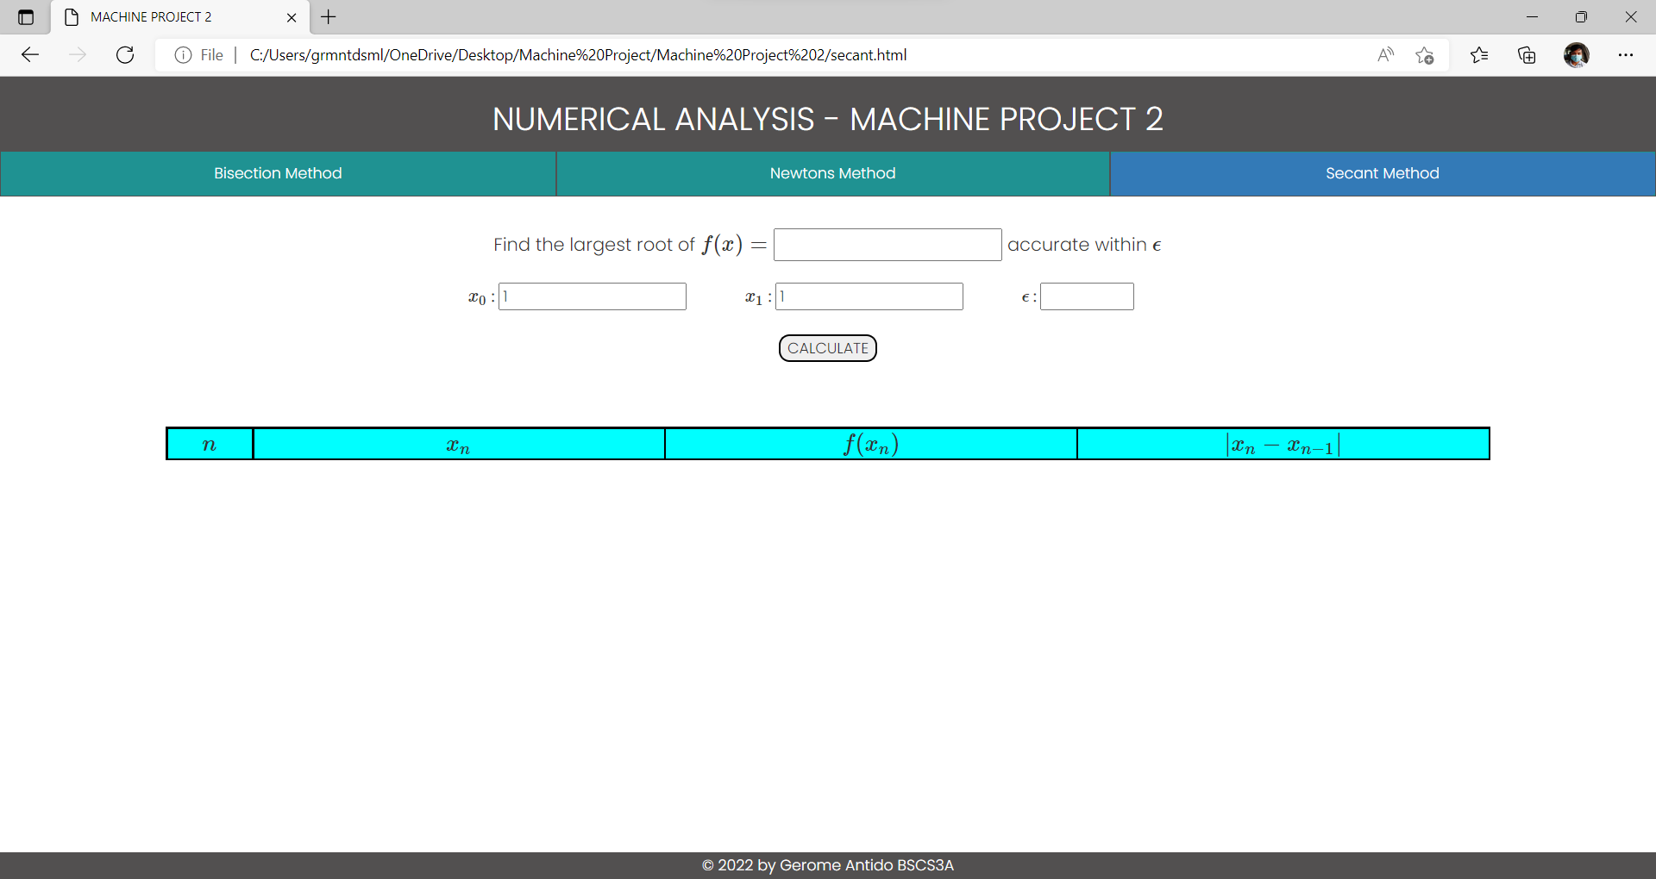

1. Input the function, initial values , and the value of epsilon. Then click the “calculate” button.

